**INTERNAL TRANSPORT RESPIRATION SYSTEM**

**Question 1**

Respiratory gases enter and leave the capillaries in the lungs by

* 1. osmosis.
  2. active transport.
  3. absorption.
  4. diffusion.

**Question 2**

In blood, oxygen and carbon dioxide are carried mainly as

1. deoxyhaemoglobin in the erythrocytes and carbonate ions in the leucocytes.
2. oxyhaemoglobin in the plasma and bicarbonate ions in the erythrocytes.
3. oxyhaemoglobin in the erythrocytes and bicarbonate ions in the plasma.
4. deoxyhaemoglobin in the erythrocytes and bicarbonate ions in the plasma.

**Question 3**

The main constituent of inspired air is

1. oxygen.
2. nitrogen.
3. carbon dioxide.
4. water vapour.

**Question 4**

Respiratory gases enter and leave the plasma in a process termed

1. Dispersion.
2. Absorption.
3. Diffusion.
4. Active transport.

**Question 5**

Cilia in the trachea ‘sweeps’ debris towards the

1. alveoli.
2. bronchi.
3. pharynx.
4. bronchioles.

**Question 6**

What is the correct passage of air into the lungs?

1. Nose 🡪 trachea 🡪 bronchi 🡪 bronchioles 🡪 alveoli
2. Nose 🡪 bronchi 🡪 trachea 🡪 bronchioles 🡪 alveoli
3. Nose 🡪 trachea 🡪 bronchioles 🡪 bronchi 🡪 alveoli
4. Nose 🡪 bronchi 🡪 trachea 🡪 bronchioles 🡪 alveoli

*Use the diagram below to answer the following question*.

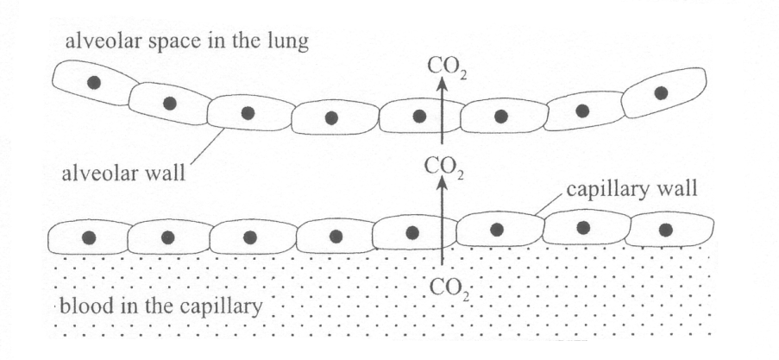

**Question 7**

Which one of the following statements about the removal of carbon dioxide from the blood is correct?

1. Carbon dioxide is moved from the blood in the capillary into the alveolar space in the lung by active transport.
2. The alveolar wall and the capillary wall are each one cell thick in order to slow the movement of carbon dioxide into the alveolar space in the lung.
3. The constant movement of the blood ensures that the concentration of carbon dioxide in the blood remains higher than that in the alveolar space in the lung.
4. The alveolar wall is spherical in order to decrease the surface area of the lung available for the removal of carbon dioxide.

**Question 8**

Complete the table below describing the changes in the respiratory system during inspiration and expiration. (7)

|  |  |  |
| --- | --- | --- |
| **Structure or Respiratory Process** | **Inspiration** | **Expiration** |
| **Diaphragm** |  |  |
| **Intercostal muscles** |  |  |
| **Thoracic cavity** |  |  |
| **Air pressure in the lungs** |  |  |
| **Lungs** |  |  |
| **Level of carbon dioxide in lungs** |  |  |
| **Level of oxygen in lungs** |  |  |

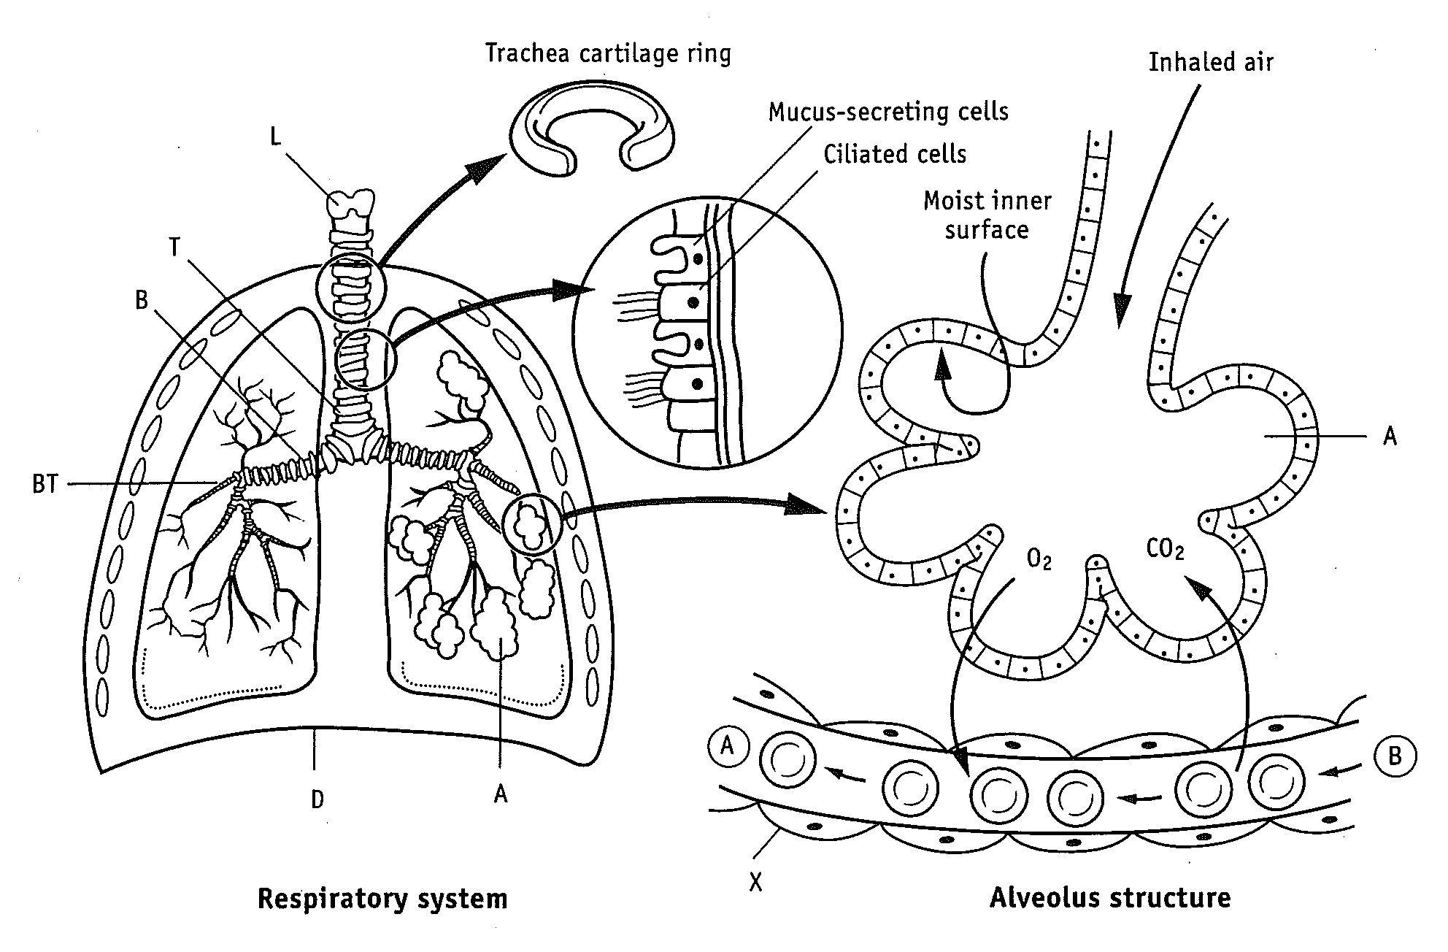

**Question 9**

Label the parts of the following parts of the respiratory system.

|  |  |  |  |
| --- | --- | --- | --- |
| L |  | A |  |
| T |  | D |  |
| B |  | X |  |
| BT |  |  |  |

**Question 10**

The diagram below refers to parts (a) to (d) of Question 10.

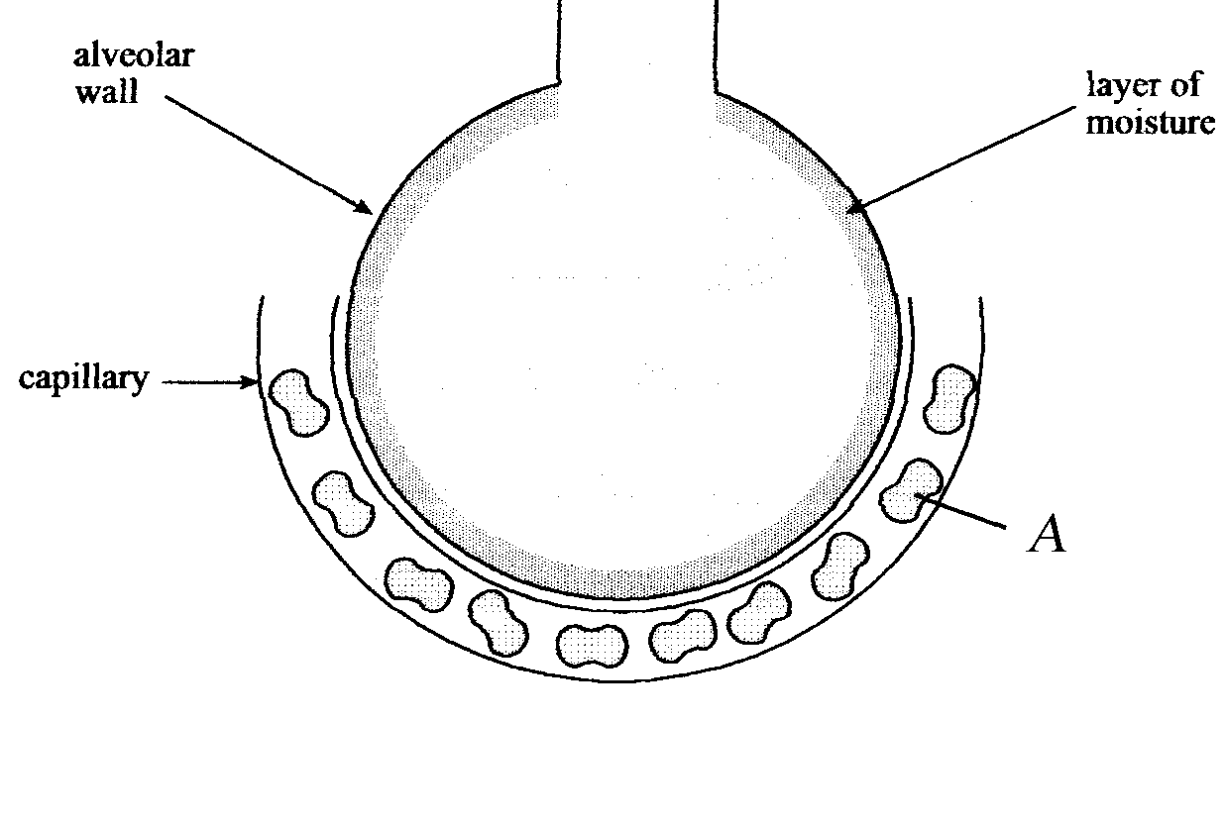

1. State **ONE** function of the layer of moisture that lines the alveolar wall. (1)

____________________________________________________________________________________________________________________________________________

(b) (i) Name **ONE** other structural feature of the alveolar wall tissue. (1)

______________________________________________________________________

(ii) State **ONE** way in which the structural feature listed in (b) (i) facilitates efficient gas exchange. (1)

____________________________________________________________________________________________________________________________________________

(c) (i) Name the structure labelled A. (1)

______________________________________________________________________

(ii) What role does it perform in the gas exchange in the lungs? (2)

____________________________________________________________________________________________________________________________________________

______________________________________________________________________

(d) Complete the following table describing how the following respiratory system

components or actions assist in normal lung function. (3)

|  |  |
| --- | --- |
| **Component of the Respiratory System** | **Function** |
| Cilia |  |
| Mucus Secretion |  |
| Coughing |  |

**Question 11**

* 1. Draw the most suitable graph from the information in the table below. (4)

**Deaths due to Lung Cancer in Males and Females in Australia**

|  |  |  |
| --- | --- | --- |
|  | **Death rate per 100** | **000 of Population** |
| **Year** | **Males** | **Females** |
| 1997  1998  1999  2000  2001  2002  2003  2004 | 51  52  50  48  47  48  47  46 | 19  18  18  19  20  19  20  21 |



* 1. Suggest additional data that you would need to collect before a relationship between smoking and lung cancer can be inferred. (1)

__________________________________________________________________________________________________________________________________________________

* 1. A carcinogen found in cigarette tar causes lung cancer.
  2. What is a carcinogen? (2)

__________________________________________________________________________________________________________________________________________________

* 1. List **THREE** carcinogenic agents. (3)

___________________________________________________________________________________________________________________________________________________________________________________________________________________________

**Question 12**

Describe the breathing mechanism of inspiration and expiration. Outline the role-played by the respiratory muscles involved and the changes that occur to the air pressure in the thoracic cavity. (10)